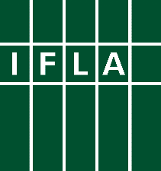

GLOBAL VISION DISCUSSION

Report of the Information Literacy Section

Standing Committee

Virtual Meeting, June 16, 2017

How a united library field can tackle the challenges of the future

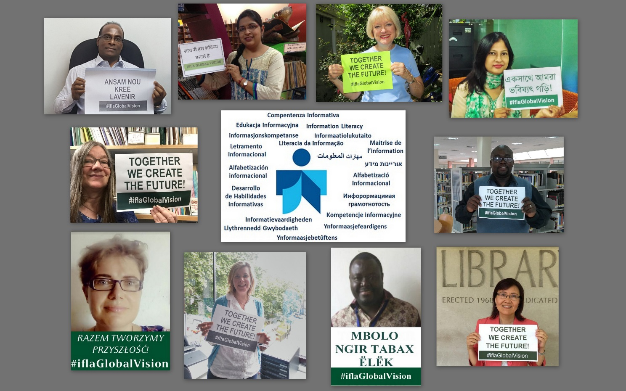

Contributors
This report is created by members of the IFLA Information Literacy Standing Committee:
Participants in virtual discussion: Min Chou, Antonin Benoît Diouf, Lisa Janicke Hinchliffe, Chhavi Jain, Ling Li, Sharon Mader, Rodney Malesi, Andrew Mwesigwa, Denise Smith, Sheila Webber, Zuzanna Wiorogórska.
Not able to be present but provided responses to Global Vision Discussion Questions: Adou Jean-Constant Atta, Laura Ballestra, Elena Corradini, Valerie Glass, Premchand Hauroo, Lian Ruan, Jane Secker.

Index
Contributors 2
Index 2
Introduction 3
A vision for libraries 4
The core values of libraries (Q4): 5
Libraries are exceptionally good at (Q5): 6
Libraries should do more of (Q6): 6
Libraries should do less of (Q7): 6
Challenges and solutions 7
The main challenges to society (Q8): 7
The main challenges to libraries (Q9): 7
The main professional challenges (Q10): 7
How a united library field can make a difference 8
How should a united library field help meet the challenges identified (Q11)? 8
The characteristics of a united library field (Q12): 8
The focus of a united library field (Q13): 9
How information literacy can help society meet the challenges identified__________________________ 7
Personal stories about the impact of information literacy_______________________________________ 8
A global conversation 10

Introduction
On June 16, 2017, via the IFLA Zoom virtual platform, eleven librarians who are members of the IFLA Information Literacy Standing Committee participated in a conversation about how a united library field can tackle the challenges of the future. Not all members were able to attend the virtual meeting, but in preparation for the discussion, a total of 13 librarians contributed responses via a Google Form to the Global Vision questions (with five doing both), for a total of nineteen members participating. Together we represent 370 years of experience in the library profession.
The participants represented 13 current IL Standing Committee members, one corresponding member, and all five of the 2017-2018 incoming members. The break-down for type of libraries is as follows: college or university library-12, secondary school library-2, municipal library-1, national library-1, LIS school-1, national library association-1, U.N. library-1. These countries are represented: Canada, China, Côte d’Ivoire, France, India, Italy (2), Kenya, Mauritius, Poland, Senegal, Sweden, Uganda, U.K. (2), United States (4).
This Global Vision discussion has provided the Section with a stimulating jumping off point for sharing a discussion on what we see as challenges and opportunities that can inform and shape shared vision and serve as a stimulus for potential action strategies for our own section. This is obviously a continuing discussion!
Some general observations: The questions almost all use the term and perspective of ‘library’ or libraries’. We would also like to see an emphasis on the human factor as the foundation. This then brought to mind how and when to use the term ‘librarian’. While librarians are the recognized professionals and leaders in the profession (by virtue of education qualifications and position), in some cases that will be the appropriate term and in others not. What kind of inclusive language can be used to represent all library workers?
There needs to be a clarification for the term “united library field’, which is sometimes stated as ‘unified library field” (so both the meaning and the phrase need to be clarified). At least one participant did not respond to the online questions due to not understanding what that meant. There is no introductory explanation, and it could be taken to be IFLA itself, or some entity in the future that will be fashioned from our vision of what should be.
A theme that came up throughout the discussion was that we need to understand and recognize the differences between different countries and different regions, and between developed and developing countries.
And as a comment on process, since most of the IFLA sections would not be able to have face-to-face meetings of their members, who are located around the globe, virtual meetings were necessary. While the organizer and facilitator guides were useful, they could have been combined, since their repetition led to some confusion, but more importantly, it would have been helpful to have a template for the discussion questions in an online format like Google Forms, so that the sections would not have had to create their own and would have had more time to devote to analysis of the discussion.
And as stated below, it was felt that the vision for the future was not far enough in the future. But it still provided a stimulating way to share what we what we value about our work and the impact it has, now and in the future.

A vision for libraries
Introduction
We are including all of the responses about the future of libraries, rather than just a sampling, because this composite presents a good picture of what we value and what we see as the role of libraries in society. Participants did comment that they felt five years wasn’t far enough in the future, and that we are already doing much of what is described. We don’t want to give the impression that these things aren’t already happening. However, no matter how far in the future we look, we would still see libraries and the people who work in them as the heart of the community, providing the space and the resources that meet and anticipate the needs of the time, with the recognition and support that they deserve.
Participants’ descriptions of libraries in the future:
Libraries enable literate, informed and participative societies. Here are the responses from IL Standing Committee members on their view of the future of libraries five years from now:
The year is 2022, and libraries have changed so much. They now, in the complex information world, are a safe place to find authoritative and good quality information to create new personal knowledge and knowledge for all. They are change agent for people in their real life and transform knowledge in books, articles, information sources in opportunity"

The year is 2022, and libraries have changed so much. They now contain less paper-based information and increasingly more electronic media. World news and local newspapers are accessible through terminals/information kiosks as users are much tech-savvy than a decade ago. Librarians forming part of a greater consortium are well connected to provide users with necessary guidance and information. All librarians have united to form a better guild for mutual aid and solving common problems. Libraries have become more inclusive, attractive, and comfortable and are centres of excellence for community activities, providing a meeting place and a platform for people to share ideas and for intercultural exchanges.

The year is 2022, and libraries have changed so much. They now have very little budgets but are still required to maintain all their resources and services. So they are doing everything to survive: renting space; organizing private events; taking charge for some of their services; limiting the opening hours to reduce the costs of building maintenance… Also, because of small salaries, the best educated librarians earn much under their qualifications, so a big number of them leave the library and search on private labor market.

In 2022, libraries are much more attractive through services and benefits. Libraries organize thematic activities to bring the communities (formal and informal) closer together and show interest in the library. At that date, libraries must offer spaces for expression and production (fablabs) in order to better assess the involvement of libraries in society. Libraries are the best community advisors.

Are heart of society and institutions in reality and not only theoretical.

The year is 2022 and libraries have changed so much. They now are responsive to individual user needs with increased rapidity. They are able to customize the experience of each individual patron (either virtual or in-person) to optimize the user experience. Libraries will continue to promote literacy, reading, access for all, but these will form the backbone of the library's activities rather than sit at the fore. Library users will engage in activities that will teach them these important principles indirectly.

The year is 2022 and libraries have changed so much. They now open to their community more, every day, from Monday to Sunday. They employ highly trained, qualified and motivated staff. Among this staff a lot of librarians are dedicated to serve the community, not only reference service but also information literacy instruction.

Primarily services with local collections focused on the unique and rare.

The year is 2022, and libraries have changed so much. They now more digitalized, all types of libraries. The public libraries work more with media and information literacy. Libraries are central in the societies and a place for everyone to be.

The year is 2022, and libraries have changed so much. Internet penetration is at its best, a large proportion of the global population has hand held devices. And remote library usage is the order of the day. I am confident that policy-makers world-wide will see libraries as a key place to engage citizenry in e-governance.

The year is 2022, and libraries have changed so much. They now are equally accessible to every community member and every citizen.

The year is 2022, and libraries have changed so much. They now have seamless reference and end-user services thanks to the full implementation of linked open data tools. There are much less printed resources and more digital ones, available for people who are members of the library. Librarians work more with people and less for resources that are acquired and immediately available to users. Librarians are facilitators of life skills, and trusted intermediators for sense-making in the process of information acquisition.

The year is 2022, and libraries have changed so much. They are evolving, as third spaces where people can work, study and relax. They are the heart of many cities and communities with integrated technology, modern facilities, however smaller branch / local libraries are less common due to funding cuts.

The core values of libraries (Q4):
- Access to information
- Equality
- Inclusion
- Intellectual freedom
- Lifelong learning/information literacy
Comments:

Libraries are exceptionally good at (Q5):
- Supporting learning, research, and scholarship and providing the appropriate environment for this
- Supporting literacy in all ages in populations of all backgrounds
- Advocating for the right of the public to have access to information
- Organization of information and sharing of resources
- Preserving historical records/documents for future generations/research
Comments:

Libraries should do more of (Q6):
- Information literacy instruction by all types of libraries and all types of people
- Advocacy and communicating with all stakeholders to ensure their support
- Networking, building bridges, cross-sector collaboration across all types of libraries
- Focus on user community needs, foster community engagement and a participatory way to look at services
Comments:

Libraries should do less of (Q7):
- Stop behaving as if they are exclusive centres to hold information, thereby overlooking competitors as providers of information
- Complaining about shortage of funds or sitting back and waiting for money to come their way instead of acting
- Be less concerned about trends and focus on remaining consistent from a service perspective; less of engaging in practices that result n low usage of the library
- Focus less on technology and more on people
- Establishing strict rules and do’s and don’ts for library users
Comments:

Challenges and solutions

The main challenges to society (Q8):
- Divisiveness and segregation
- Inequality (of all types)
- Cybersecurity challenges
- Funding
- Dealing with refugees and others in disadvantaged situations
Comments:

The main challenges to libraries (Q9):
- Funding for libraries at all levels
- Buy-in from policy makers and the community (who don’t always see the value of libraries)
- Competition from other information providers – Why do we need libraries? What is unique about what libraries can offer?
- Need to emphasize the role of the librarian and of all the people who work in libraries – the skilled human beings, not just the library as an entity
Comments:
When is it appropriate and useful for the context to use the term ‘librarian’? In what cases does this represent the overall profession and in what cases might there be varying perspectives and needs? What more inclusive language can we use to represent all of the people who work in libraries, not just librarians? Some terms that have been used: staff, allied staff, library workers. Need to be sensitive to how and where we use the term ‘librarian’.

The main professional challenges (Q10):
- Leadership and professional recognition
- Professional development
- To unite all people in the LIS sector under one robust library association and to create an effective network across regional and international levels
- To be an educator and to provide and educational environment for users
- To keep up-to-date with current professional trends
Comments:

How a united library field can make a difference

How should a united library field help meet the challenges identified (Q11)?
- Professional networking and support; collaboration on a global level, across different types of library sectors to establish a unified approach all types of libraries; collaborations across regions, especially between developed and developing areas (e.g., North to South) and how to make this more formal
- Creating a solidarity among librarians and a sense of belongingness to the profession; making core values clearer
- Leadership – to make our voice heard in society, not just for ourselves; to articulate the value of libraries and to share with stakeholders
- Advocacy and actions that have a legal impact; declarations, statements, guidelines, recommendations, etc., are not enough (especially given the lack of funding)
- Manifestos, guidelines, and other such documents can serve to provide a standard approach to help librarians across the world. (Note that #4 and #5 conflict – this may reflect situations and needs in different parts of the world.)
Comments:

The characteristics of a united library field (Q12):
- A common voice for all librarians throughout the world
- Supportive, collaborative, multi-national, sharing experiences
- Inclusive – for user communities and for the library field; cuts across gender, race, educational levels in librarianship and welcomes working relationships and affiliate memberships with other professions and disciplines
- Professionalism
- A platform to meet and exchange worldviews, missions, and goals, to adapt to the changing information environment
Comments:

The focus of a united library field (Q13):
- Build capacity in all regions of the world through strong LIS education
- Make libraries a stronger and more significant player in the community
- Develop best practices and standardization of library services
- Make the library a great democratic institution, serving people of all ages, incomes, ethnicity, religions, physical abilities, etc. and providing the full range of services and resources to meet their needs
- Support for the core values of libraries, of the value of libraries and the professional librarian to society; a shared vision and agenda
Comments:

How information literacy can help society meet the challenges identified (Q14):
(Added for the Information Literacy Section discussion)
- The contribution of each citizen in the political sector and their active participation in the democratic set-up may only be ensured if they are information and media literate. This also recognizes that there are many countries where a democratic society does not exist, so the means for achieving information and media literacy may be different but will still be necessary.

- Eradication of absolute poverty, digital divide and other socio-economic problems may be tackled only by a fully literate society.

- Information literacy can enhance lifelong learning and gives children and adults the skills they need to survive and thrive in a global information society.

- Information Literacy is central to addressing these challenges - it underpins everything that libraries do and stand for; to be information literate is a need of our communities and once this is understood, libraries and librarians can meet these challenges

5.
Comments:

Personal stories illustrating the impact of information literacy (Q15):
(Added for the Information Literacy Section discussion)
Being in Vietnam now, I observe every day how the low level of information skills makes life more complicated and less rich in solutions. And how libraries and librarians (because of many factors) do little to change this situation. It makes me very sad. Particularly that I know how little is needed to change much. Off Q14/15 topic: In 2005 I took part in a library essay contest titled “My workplace in 2015”. I described the vision of my future. Now we have 2017, and really not much has changed since 2005… Of course, I got promoted, I developed many skills and so on. But honestly, there was no revolution, new opening or earthquake. Only budget cuts all the time… And here we need to draft a 5-year perspective (global vision). Does anyone really think something will change?

In my professional career, my interests are focused on the use of technologies in libraries (that includes information literacy), which enabled me to initiate a documentary web portal which is agreed by my institution. Since then, I share my experience and my opinions on the use of library technologies and especially the need to be well trained to meet challenges in documentary communication. The impact of that is that the documentation system of my institution has become like a model in terms of initiative of technologies in libraries and librarians, examples of leadership. I am involved in any national initiative of information dissemination in my country.

Now my students or young library users are more confident in finding information from various resources. They enter in library with the intention of learning something new and even new techniques of information literacy.

I have heard several library users drawn from different professions coming to ask reference queries based on their careers. I have been able to develop some training that can address these issues.

My library is part of the state statutory fire training academy. We have consistently trained firefighters (more than 42,000 state-wide) how to use and evaluate information so they can improve their training and emergency responses in the past 20 years. The library's impact is far-reaching and touching.

Our municipal library offers a room for Italian language crash courses held by mother tongue teachers to the benefit of refugees. One of them, during the last school year, has acquired good skills and has got a job that allowed him to be recognized as a future EU citizen.

In the UK we have funded a project for refugees from Syria to show how information literacy skills can support their re-settlement into a local community in Scotland. Their need for information at this critical time in their lives and the types of support they might need were highlighted in this project. Libraries in Aberdeenshire provided a central role in the project.

A global conversation
This report has been created through an interactive process, during a virtual meeting on the IFLA Zoom platform on June 16, 2017 and pre-and post-meeting contributions through the Google question Form. It is part of a global conversation initiated by IFLA on how a united library field can tackle the challenges of the future.
Over the course of two years (2017-2018), IFLA will involve as many librarians and others as possible in this global conversation. Participants are encouraged to continue the conversation in their own networks and organization and share the results with IFLA. At the end of 2017, the first results of all the workshops and online discussions will be turned into a Global Vision Report, which in turn will be adapted into concrete strategies, processes and work programmes in 2018.
To learn more about the global conversation, and download supporting materials to support your own activities, visit globalvision.ifla.org.
Stay tuned for news about the IFLA Global Vision discussion following #iflaGlobalVision and make sure to cast your vote in August when the online voting platform is available on https://globalvision.ifla.org/.

