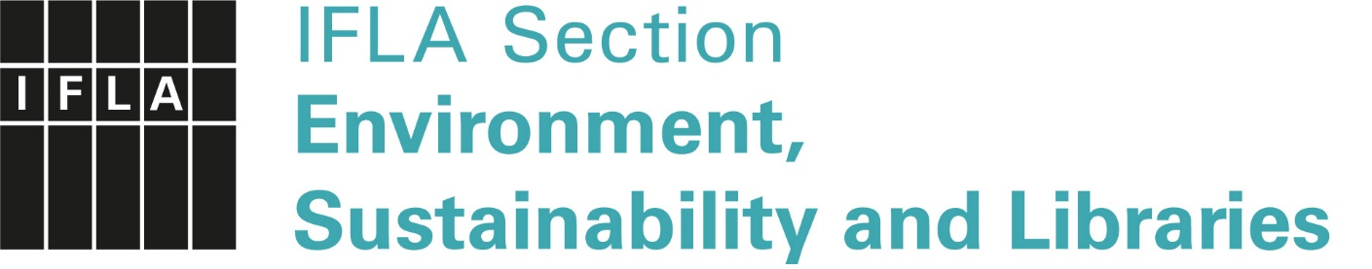
ENSULIB Action Plan 2020-2021: Abstract
Environment, Sustainability and Libraries Special Interest Group (Section) looks towards active period 2020–2021. The transition from SIG to Section has been realized with the achievement of 61 institutional memberships, plus 4 personal affiliates. ENSULIB will begin as a section January 2021 with an interim Standing Committee. The first Standing Committee will be selected in spring and it will begin its work in August 2021.
Other focus areas for 2020–2021 are as follows:
- IFLA Green Library Award 2021: we will develop the award, increase visibility and participation, and create new evaluation criteria for selection. Criteria will serve as guidelines for green library applicants and offer some self-evaluation tools for libraries, whether they are selected or not.
- Book Project “New Libraries in Old Buildings: Creative Reuse”. The book will be published within IFLA publication series (no. 180) in print and open access formats in February 2021.
- IFLA WLIC 2021: ENSULIB will host a virtual Open Session with Library Buildings and Equipment Section with a shared theme, postponed from WLIC 2020, “New Libraries in Old Buildings”. A special session with IFLA Green Library Award winners (2020 & 2021) will offer presentations.
- Disseminating the Green Library concept through participation in national and international conferences and publications: Seminar/Workshop/Webinar/Non-WLIC Event
- Promotion of Green Libraries: Green Library Conference, Satellite conference and UN SDGs. Showcase the power of libraries in achieving the Sustainable Development Goals - By supporting green libraries to publish their stories at the IFLA SDG website, ENSULIB increases IFLA’s visibility and ability to deliver high quality, high impact and engaging communications tailored to the needs of the global library and information community.

