IFLA RSCAO Sub-Regional Report, [Place of Meeting, e.g. Kuala Lumpur, Malaysia], [Year of Meeting, e.g. 2018]

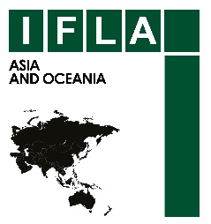
IFLA - Regional Standing Committee for Asia and Oceania

(IFLA - RSCAO)

Bi-annual Sub-Regional Report

[Reporting Period, e.g.
April – July 2018]

Sub-region: |  | Convenor.:
Date of submission:

- Achievements in the key roles and responsibilities as sub-regional convenor:

- Promotion of IFLA and IFLA-RSCAO and its programs and activities in the sub-region (Please provide details):

- Encourage professional colleagues in the sub-region to join IFLA and its activities (Please provide details ):

- Work closely with the Regional Office and organizers, if a country in the sub-region has been selected to host the mid-term meeting (Please provide details):

- Arrange and upload photos and short write ups of activities for the RSCAO Facebook page ( Please Provide details):

- Other activities, if any (Please provide details):

- Brief details with links to information where available, of two (2) most impactful activities in each country in the sub-region, for example, activities of: library association/s; different types of libraries; library studies programs; any conferences, workshops or seminars and so on. Please add more rows, etc. as required.

Country | Activities | Impact
Name: | #1 Name and Date:  Details
#2 Name and Date:
Details

Name: | #1 Name and Date:  Details
#2 Name and Date:
Details

Name: | #1 Name and Date:  Details
#2 Name and Date:
Details

Name: | #1 Name and Date:  Details
#2 Name and Date:
Details

